Note: You can select delegates to prepare documents for you in this page. However, this page will not allow you to select delegates to approve other employee’s documents on behalf of you. To select delegates to approve, complete “Concur Supplemental Form for Employee Access Updates” and submit it to Kirk Williams (kawilli4@central.uh.edu) or Catherine Chan (cchan@central.uh.edu).

Step 1: Login to Concur and click on “Profile”, and click on “Profile Settings”.
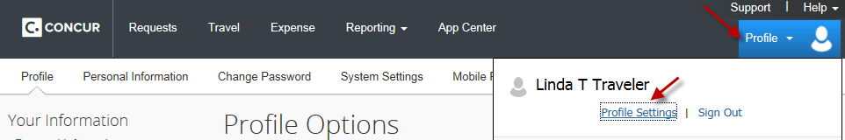

Step 2: On the menu, select “Expense Delegates”
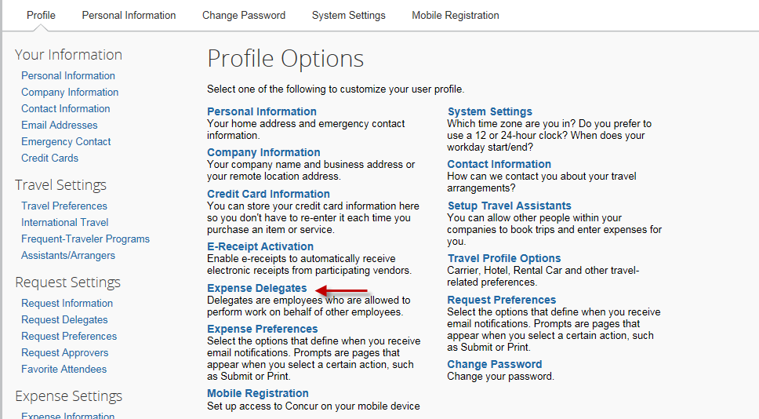

Step 3: You are now in the Expense Delegates page. Click on “Add”.
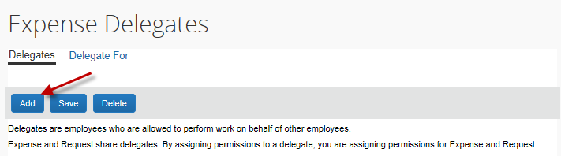

Step 4: Enter an employee who can prepare Travel Requests and/or Expense Reports for you. Then click on “Add”.
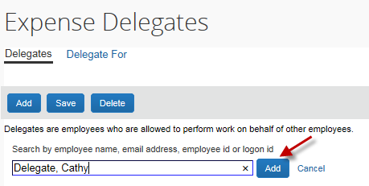

Step 5: Place a checkmark in the appropriate boxes. Then, click on “Save”.
